Change Password

Turn Firewall on: netsh adv firewall set allprofiles state on

Go into advanced settings and clean up inbound rules

Add routes: route add 172.25.34.0 MASK 255.255.255.0 172.31.34.2

Set Up NTP

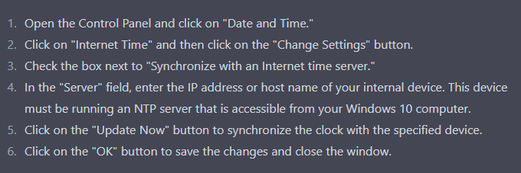

Set up Logon Banners

